**Google Bellabeat Capstone Project**

1. About the company:

Urška Sršen and Sando Mur created Bellabeat, a health firm, in 2013. The firm is recognized for its smart gadgets focused at women, which promote a better lifestyle. Some of its well-known goods are:  
**Leaf** :A health tracker that measures movement, sleep, and reproductive health.  
**Time** :A smart health watch that monitors exercise, sleep, and stress levels.  
**Spring**: A smart water bottle that monitors your regular water intake.  
**Bellabeat App**: A mobile app that allows users to view their health data and receive tailored wellness advice.

1. Objective:

The case study's goal is to use Bellabeat's data to develop insights that can aid the company's business strategy, particularly in increasing its market reach. The purpose of evaluating this data is to give crucial insights into user behavior and trends, as well as meaningful recommendations for how Bellabeat may boost user engagement, expand its client base, and improve its marketing approach.

1. Key Stakeholders:

* **Executives at Bellabeat**: They are in charge of using the information obtained from the data analysis to inform strategic business choices.
* **Marketing Team**: Using the results, they would create focused advertising campaigns to draw in new clients and keep existing ones interested.
* **Product Development Team**: This team can improve current products or create new ones by using insights into consumer behavior.
* **Present Bellabeat customers**: Since they gain from improved goods and services, they are indirectly stakeholders.

1. Data Source:

The FitBit Fitness Tracker statistics, a publicly available dataset including anonymized use statistics, is the source of the data. It monitors several parameters, including: **Daily activity**: Steps, distance, calories burned, and active minutes.

**Heart rate**: Resting and active heart rate data.

**Sleep patterns**: Sleep duration and quality metrics.

**Other health-related metrics**: Weight, BMI, and hydration levels.

1. Key Questions(ASK):
   * 1. How frequently do users engage with Bellabeat devices and apps?
     2. What are the common activity levels (e.g., steps, calories burned) and sleep patterns among Bellabeat users, and how do these compare to health recommendations?
     3. What customer segments (age, location, health behavior) engage the most with Bellabeat products, and how can Bellabeat expand into new market segments?
2. Prepare the Data :

The data has been organised in the form of csv files. The csv files are loaded and converted into data frames for the next steps. Furthermore , the datatypes and other information regarding the data is being revealed in this step.

Due to its small sample size (usually only 30 users), reliance on third-party data from Amazon Mechanical Turk, and outdated collection date, Bellabeat data is generally regarded as having low credibility. This means that it is not entirely representative of the larger female population and may not be trustworthy for making important inferences about user behavior and trends.

1. Process the data: The data in this process has been converted from dirty to clean and hence ready for analysis. Following are the steps taken in this phase:

* Removing duplicates
* Checking for null values and taking actions to resolve the issues with it(In this case ,the column was dropped since it was not needed for the analysis).
* Data types were checked and formatted for the necessary columns.
* Checking for unique values

1. Analysis:

A.User Engagement:

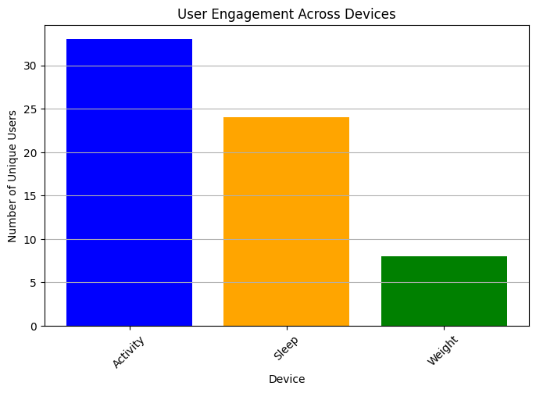

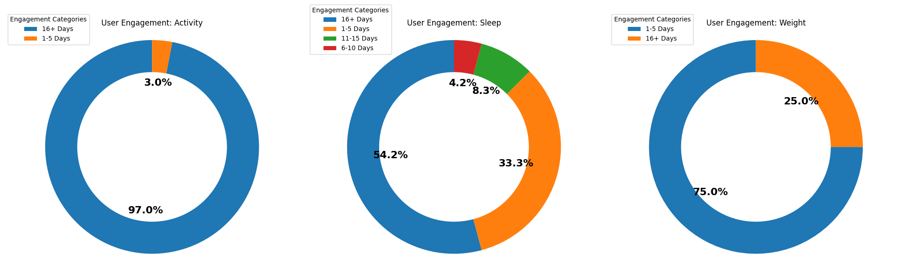

B. User Distribution for activity levels

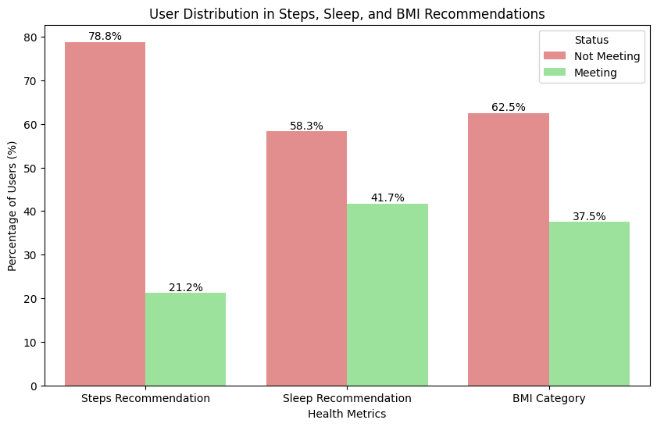

C. User engagement for the categories across all 3 devices

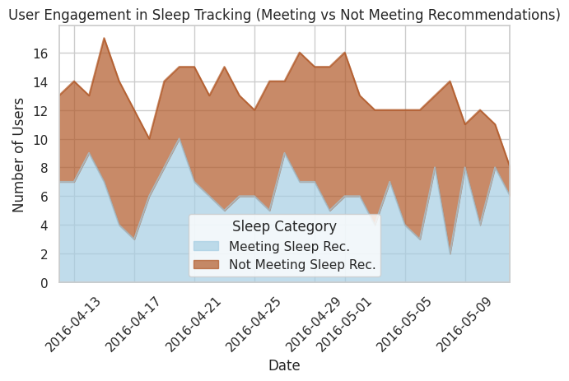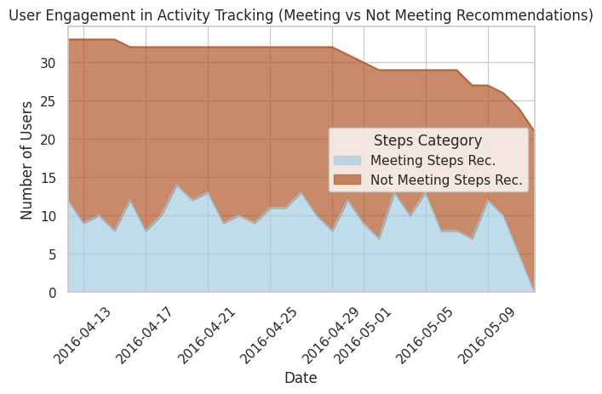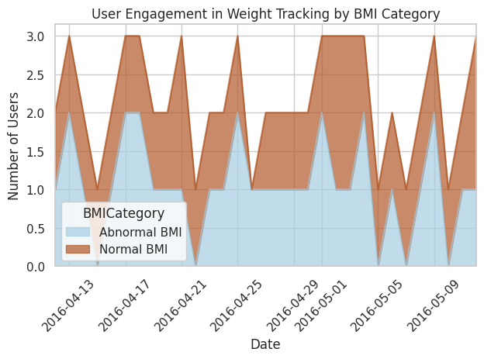

1. Share

How does the performed analysis answer the key questions?

1.How frequently do users engage with Bellabeat devices and apps?

Overall User Engagement Across Devices:

Activity Tracking: This device has the highest engagement, with over 30 unique users actively using it.

Sleep Tracking: Moderate engagement is observed here, with around 25 unique users.

Weight Tracking: This device shows the least engagement, with fewer than 10 unique users.

Frequency of User Engagement:

Activity Tracking: Nearly all users (97%) engage with the device for more than 16 days, indicating very high consistency in use, with only 3% engaging between 1-5 days.

Sleep Tracking: Engagement is more varied. 54.2% of users engage between 1-5 days, 33.3% for more than 16 days, and smaller percentages fall into the 6-10- and 11-15-days categories.

Weight Tracking: Most users (75%) engage for 1-5 days, while 25% engage for more than 16 days, indicating that weight tracking is less frequently used compared to the other devices.

In summary, users most consistently engage with activity tracking, while engagement with sleep and weight tracking is less frequent, with weight tracking being the least consistently used feature.

2.What are the common activity levels (e.g., steps, calories burned) and sleep patterns among Bellabeat users, and how do these compare to health recommendations?

The results from the analysis of Bellabeat users' adherence to health recommendations are as follows:

Steps Recommendation: 78.8% of users are not meeting the recommended daily step count (10 k steps) , while 21.2% are meeting it.

Sleep Recommendation: 58.3% of users are not meeting the recommended sleep duration (7-9 hrs), while 41.7% are meeting it.

BMI Category: 62.5% of users do not fall within the recommended BMI range (normal BMI- within 24.9), while 37.5% do.

These results highlight that the majority of users are not meeting recommended levels for steps, sleep, and BMI.

3.What customer segments engage the most with Bellabeat products, and how can Bellabeat expand into new market segments?

A. For activity data: From the graph, we can observe that there's a core group of highly engaged users (consistently meeting step goals - blue area) representing roughly 30-35% of the user baseHowever, there's a larger segment (65-70%) not meeting activity goals, suggesting an opportunity for improved engagement strategies.

B. For sleep data: From the graph, we notice that both the categories: Sleep meeting recommendation and Not meeting sleep recommendation show almost equal engagement throughout. However, the in-total engagement decreases in the month of May.

C. For weight data: Firstly, the number of users who are active make u to 3, which is very less. To add to this, the proportion of engagement of the users meeting normal BMI and not meeting the normal BMI is mostly the same. In conclusion, the data to perform this kind of analysis is too little to tell.

1. Act

In this phase, I will propose few of the marketing strategy to promote user engagement based on the above analysis.

1. Increase Engagement with Key Devices with Activity Tracking: Because this device has the highest engagement, tactics should focus on retaining and improving customer loyalty and happiness through activity monitoring features. Consider the following approaches:

Gamification & Challenges: Create weekly or monthly exercise challenges (e.g., "30-Day Step Challenge") and reward or recognize people who fulfill them. Users who are already highly involved would welcome additional motivation, whilst less engaged users may be urged to join.

Social Sharing and Community Building: Implement a tool that allows users to share their achievements with friends or within a Bellabeat community.

Personalized alerts: Send alerts with personalized insights on progress toward step objectives, such as motivational reminders or nudges, focusing on the 65-70% of users who do not consistently fulfill targets.

2.Sleep Tracking: With small engagement and a noteworthy reduction in May, a few smart changes might assist raise interest and usage.

Educational Campaigns: Share sleep-related material via email and in-app messaging, such as advice for improving sleep quality and the health advantages of sleeping the prescribed hours. Offer targeted advice to people who are not getting enough sleep.

Seasonal Re-engagement: Given the reported dip in May, consider launching a focused marketing campaign around this time. Offer limited-time incentives or add additional features to improve the sleep monitoring experience (for example, calming sounds or individualized sleep advice).

3.Weight monitoring: Because engagement with weight monitoring is minimal, seek to reposition this feature to highlight its long-term advantages.

Goal-Based Programs: Include weight management programs in the app that guide users in setting realistic goals and taking concrete measures to achieve and maintain a healthy BMI. Users that track their weight on a regular basis for an extended length of time may win badges or awards.

Cross-Promotion: Encourage weight tracking by linking it to other Bellabeat features. For example, highlight the synergy between exercise and weight tracking to demonstrate how they complement overall health objectives.

In addition to this ,users can be provide with personalised health coaches that could help them gain their normal BMI range via exercise and nutrition intake.

All in all ,the above strategies can promote the user engagement along with some sort of advertising(social media or any platform to reach the target audience) since tailoring ads for sleep and weight segment of bellabeat currently have low number of users.